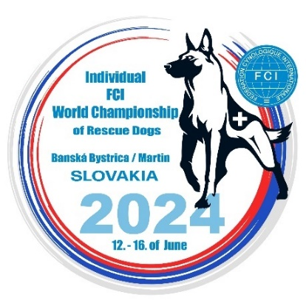

APPLICATION FORM

Closing date for entries: 05.05.2024 send to e-mail: registration@fciwch2024rescuedogs.sk

Country
National Kennel Club
Team leader (TL) Name
TL e-mail
TL mobile phone
Address

FCI Languages spoken

The Application form at FCI Individual World Championship of Rescue dogs,
Banska Bystrica / Martin (Slovakia), 12 - 16. 06. 2024
at follow categories with that numbers of dogs:

AREA SEARCH ( ) dogs
RUBBLE SEARCH ( ) dogs
TRACKING ( ) dogs
UNIVERSAL ( ) dogs

I declare that we respect the specification for the organisation of FCI World Championship for Rescue Dogs and the organizer decisions.
With the Registration forms we have transferred the tax fee for each dog, we will send the pictures, the Veterinary book and the Results book of each dog present at event.

Participation Fee: 115 euro / dog, until 12.05.2024, must be sent to:
Name of Association: DOG RESCUE SLOVAKIA - Kynologická záchranárska brigáda Banská Bystrica
Address of Association: Na Lúčkach 14220/12, 974 09 Banská Bystrica – Podlavice
Bank: Slovenská sporiteľňa, a.s.
Address of Bank: Tomášikova 48, 832 37 Bratislava, Slovenská republika
IBAN: SK27 0900 0000 0052 1087 5019
SWIFT: GIBASKBX

Date: ..................... Representative of National Kennel Club Signature ....................................

