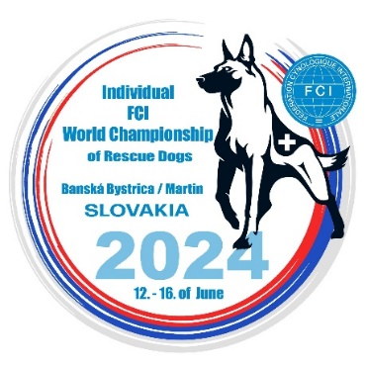

REGISTRATION FORM

Closing date for entries: 12.05.2024 send to e-mail: registration@fciwch2024rescuedogs.sk
Country
National Kennel Club
Team leader Name
TL e-mail
TL mobile phone
Address

IPO-R | Dog handler’s Name | Name of dog | FCI Breed code | Chip number | Dog’s DOB
FL 1
FL 2
FL 3
FL 4
FL 5
FL 6
T 1
T 2
T 3
T 4
T 5
T 6
F 1
F 2
F 3
Res

I declare that we respect the specification for the organisation of FCI World Championship for Rescue Dogs and the organizer decisions.
For the Universal specialty - that dog must be found in each specialty, on this table.
With the Registration form we have transferred the participation fee for each dog, will send the pictures, the Veterinary book and the Results book of each dog present at event.

Date: ..................... Representative of National Kennel Club Signature ....................................

